Tasks for App and Web servers

Install Apache and run Apache on port number 82:
Yum install httpd -y : to install the nginx
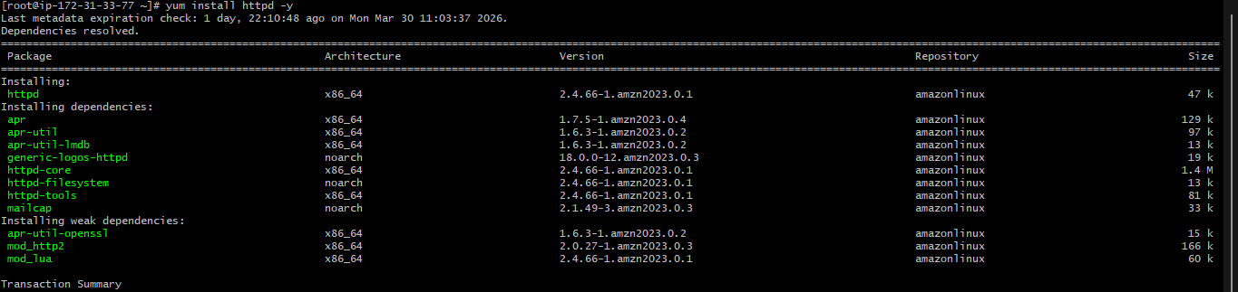
Systemctl start httpd: to start the service
Systemctl status httpd: to check the status of the service
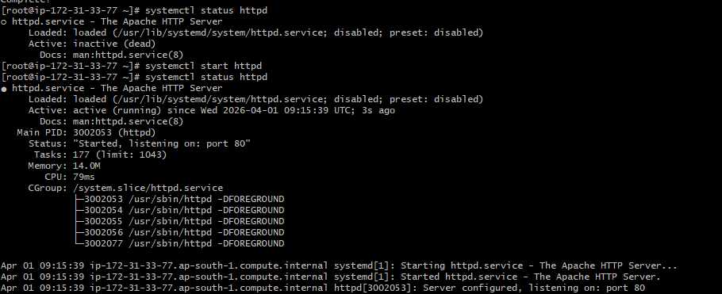

Go to the browser hit the public ip: portnumber
Example: 13.233.232.97:80


We can change the port number in httpd.conf file
Cat /etc/httpd/conf/httpd.conf : in this path we can change the port number
Ex: change port number as 82
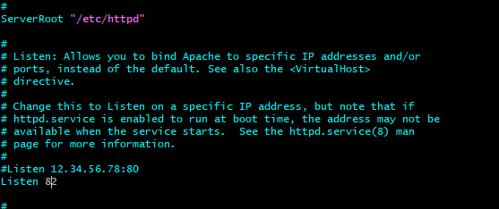


Defult deployment location for httpd: var/www/html
Here we can create index.html and deploy the content


Install nginx and run nginx on port number 81:
yum install nginx -y : to install the nginx
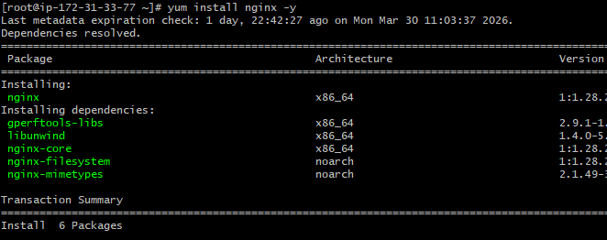
Systemctl start nginx: to start the service
Systemctl status nginx: to check the status of the service
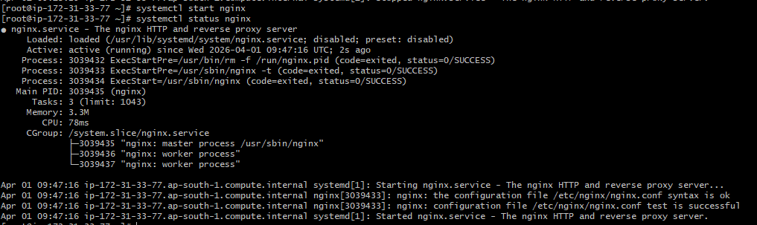
Go to the browser hit the public ip: portnumber
Example: 13.233.232.97:80
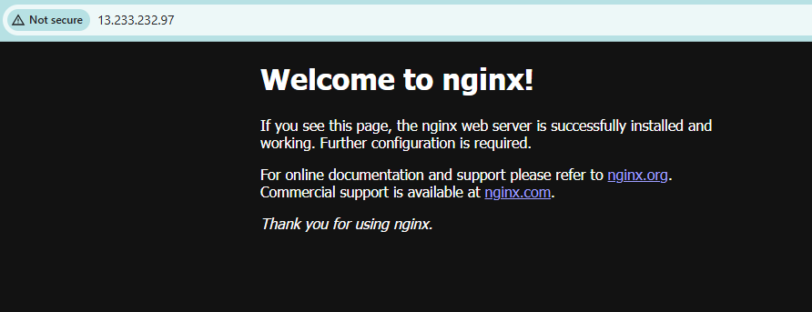
Defult deployment location for httpd: usr/share/nginx/html
In this path we have index.html file we you can make changes in the file and it shows browser
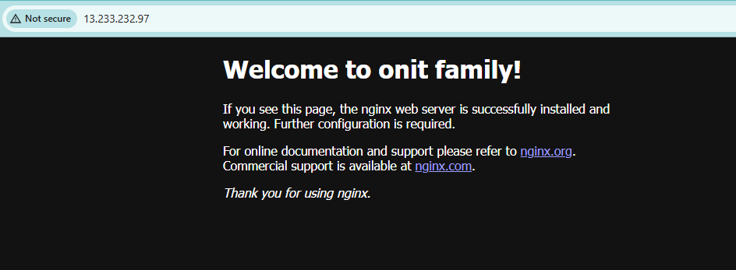
We can change the port number in nginx.conf file
Cat /etc/nginx/ngin.conf : in this path we can change the port number
Ex: change port number as 81


Install Apache tomcat on port number 8082:
wget ‘tomcate application link from the browser’: to install the tomcat

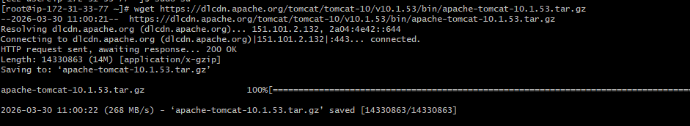
Java is prerequisite of apache tomcat
Install the java using yum insatll java -y
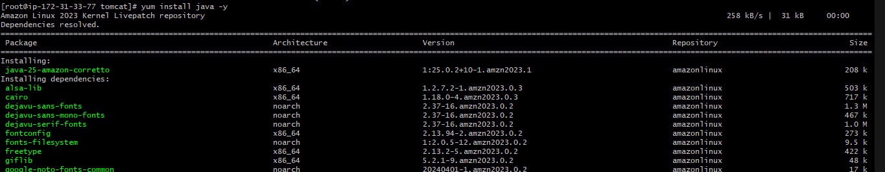
./startup.sh : to start the tomcat
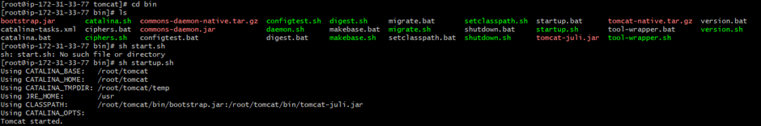
Go to the browser hit the public ip: portnumber
Example: 13.233.232.97:8080
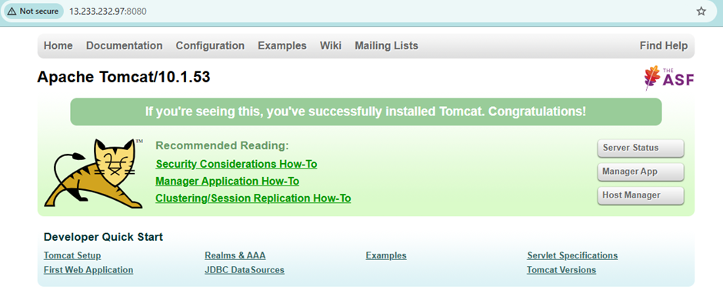
We can change the port number in httpd.conf file
Cat /etc/httpd/conf/httpd.conf : in this path we can change the port number
Ex: change port number as 82

We can change the port number in httpd.conf file
Cat /tomcat/conf/server.xml : in this path we can change the port number
Ex: change port number as 8082

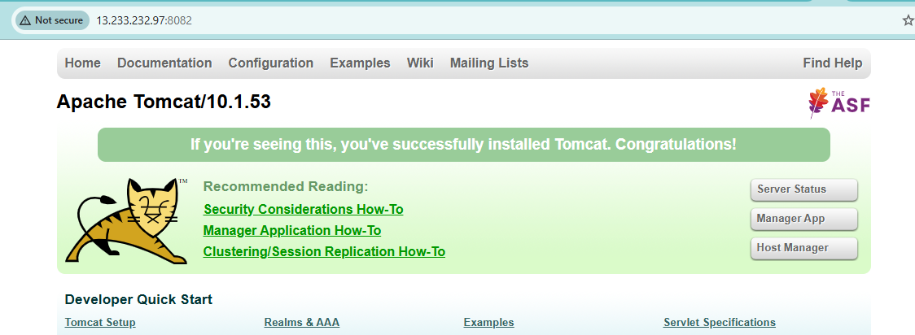
/tomcat/webapps: in this path we are download simple.war application by using wget command

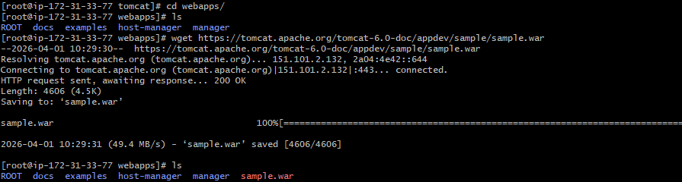
Go to the browser hit the public ip: portnumber
Example: 13.233.232.97:8082

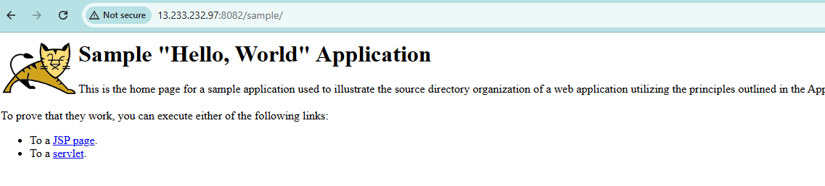

/etc/systemd/system : create tomcate.service file and write configuration and save it
And chesk the status by using systemctl status tomcat , it display the status
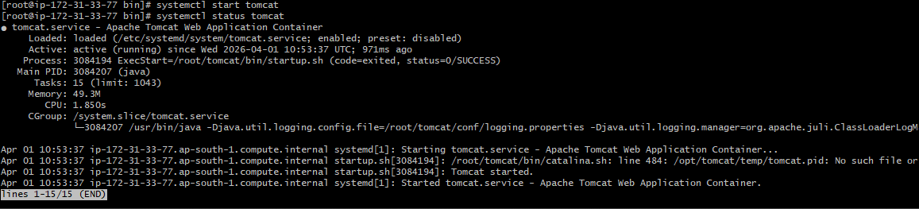
Configure HA Proxy server:
Yum update -y
Yum install httpd -y
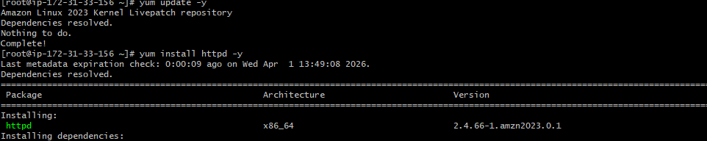
Vi /etc/hosts
• Add HA-Proxy-Server Pubic IP Address
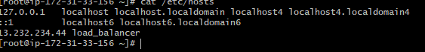
Ping load_balancer -c 4
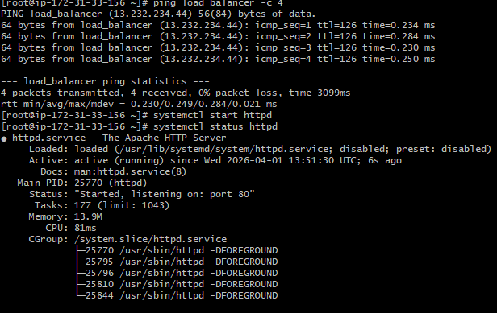

Access to server -2
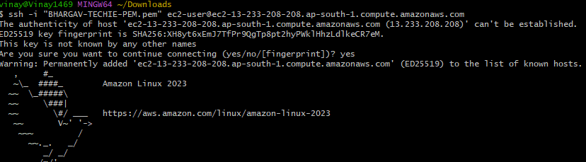
Yum install nginx -y
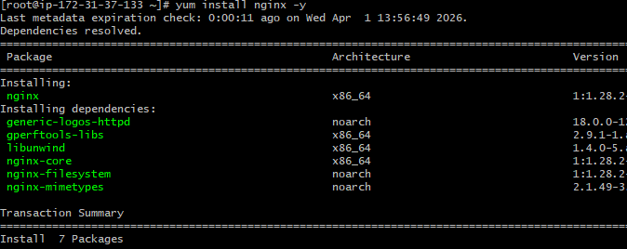

Vi /etc/hosts
Add haproxy server ip
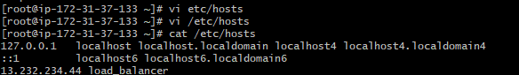
Ping load_balancer -c 4
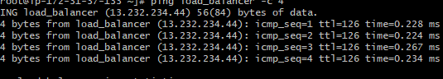

Systemctl start nginx
Systemctl status nginx
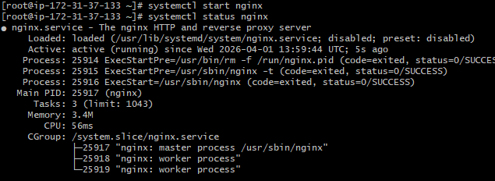
Access to the haproxy server
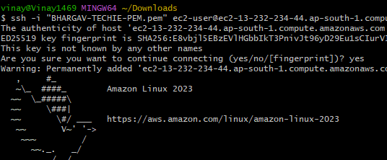
Yum install haproxy -y
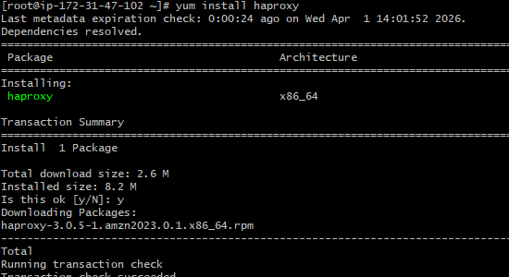

Vi /etc/hosts
Add server1 server2 ip’s
Vi /etc/haproxy/haproxy.cfg
Add server1 server2 ip’s
Systemctl enable haproxy
Systemctl start haproxy
Systemctl status haproxy
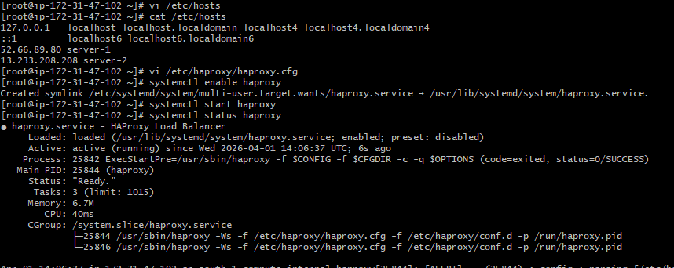
• now browse with HA-Proxy-Server PublicIP:80 it will distribute load to Server-1, Server-2

